4.1 Useful things B
- Popatrz na obrazki i uzupełnij wyrażenia.

0 | 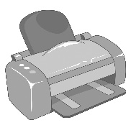 | 1 | 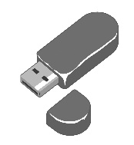 | 2 | 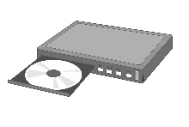 | 3 | 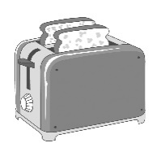

4 | 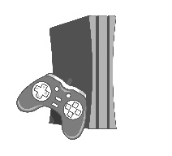 | 5 | 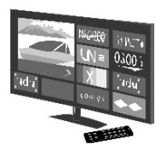 | 6 | 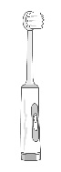

7 | 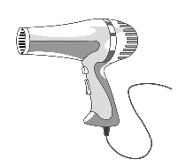 | 8 | 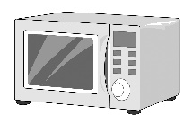 | 9 | 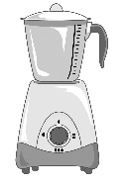 | 10 | 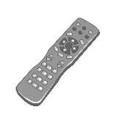
- p r i n t e r
- USB s _ _ _ k
- DVD p _ _ _ _ r
- t _ _ _ _ _ r
- g _ _ _ s c _ _ _ _ _ e
- s _ _ _ t TV
- e _ _ _ _ _ _ c t _ _ _ _ _ _ _ _ h
- h _ _ _ _ _ _ _ r
- m _ _ _ _ _ _ _ e o _ _ n
- b _ _ _ _ _ r
- r _ _ _ _ e c _ _ _ _ _ l
______ / 10

4.2 Using technology B
- Uzupełnij zdania wyrazami z ramki.
in off on press unplug
- Press this button to start the laptop.
- _______________ the fridge, please. I want to empty it and clean it.
- Please turn _______________ the radio. I want to listen to the football results.
- Please turn _______________ the lights before you go to bed.
- Plug _______________ the computer and connect to the Internet.
______ / 4
4.5 Smartphones B
- Wybierz poprawne odpowiedzi.
- Where are my headphones / ringtones? It’s late but I want to listen to music.
- Is there battery / Wi-Fi here? I want to connect to the Internet.
- I always take a touch screen / portable charger with me so I can use my tablet for more hours.
- His ringtone / battery is his favourite song.
- Don’t put your dirty fingers on your app / touch screen. Wash your hands first.
- My phone isn’t working because the mouse / battery is at 0%!
- This is a useful app / Wi-Fi and you can download it to your phone or computer.
______ / 6
Total score: ______ / 20

