3.1 Going on holiday B
- Popatrz na obrazki i uzupełnij wyrażenia.
0 |  | 1 | 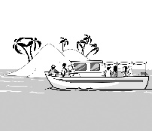 | 2 | 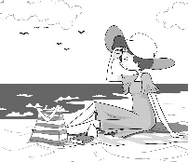 | 3 | 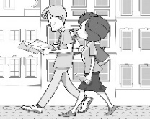 | 4 | 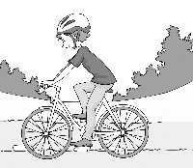 | 5 | 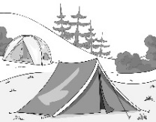

6 | 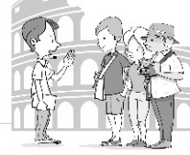 | 7 | 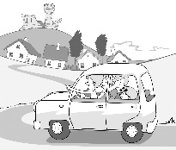 | 8 | 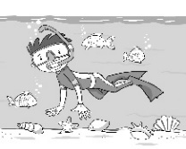 | 9 | 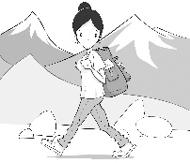 | 10

- read a g u i d e b o o k
- go on a b _ _ _ t _ _ _
- go on the b _ _ _ _
- e _ _ _ _ _ _ a city
- go c _ _ _ _ _ _
- go c _ _ _ _ _ _
- go on a g _ _ _ _ _ t _ _ _
- go on a d _ _ t _ _ _
- go s _ _ _ _ _ _ _ _ _ _
- go h _ _ _ _ _
- t _ _ the local f _ _ _
______ / 10

3.5 Phrases with get B
- Popatrz na obrazki i uzupełnij zdania słowami z ramki.
0 | 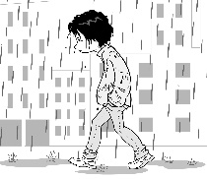 | 1 | 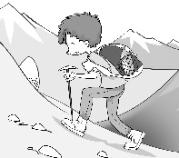 | 2 | 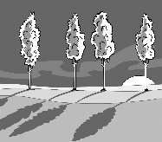
3 | 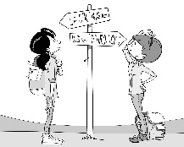 | 4 |  | 5 | 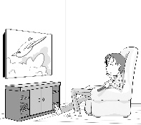
bored cold dark lost tired wet
- Tim is getting wet because he hasn’t got an umbrella.
- Alfie wants to rest. He is getting _______________.
- It’s late and it’s getting _______________.
- Jane and Lily went for a walk and got _______________.
- It’s getting _______________. Sarah needs a jumper.
- Mark gets _______________ because he sits in front of the TV all day.
______ / 5
Total score: ______ / 15

