4.1 Geographical features B
1 Dopasuj słowa z ramki do elementów krajobrazu przedstawionych na obrazku.
beach city desert forest island lake mountain river
sea town volcano waterfall
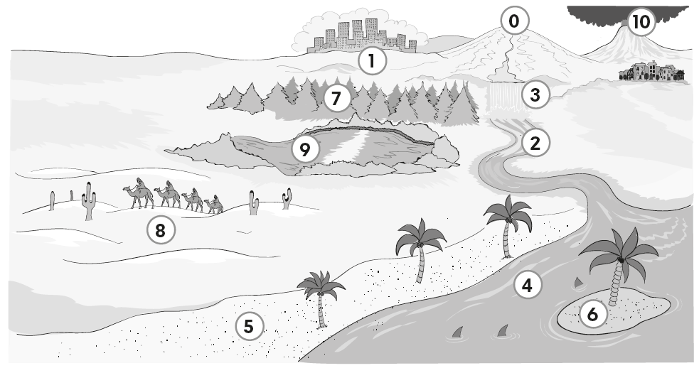
0 mountain
1 _______________
2 _______________
3 _______________
4 _______________
5 _______________
6 _______________
7 _______________
8 _______________
9 _______________
10 ______________

______ / 10

4.2 Adjectives (1) B
2 Uzupełnij zdania przymiotnikami o znaczeniu przeciwnym do podkreślonych słow.
0 I’m going for a short walk today. I don’t want to go for a long walk.
1 This mountain is low. Mont Blanc is a h____________ mountain.
2 They can do the e____________ exercises but they can’t do the difficult exercises.
3 I want a cheap phone. This mobile phone is too e____________.
4 Don’t go sailing in this bad weather. It isn’t s____________. It’s dangerous.
5 That DVD isn’t boring. I love it! It’s e____________.
______ / 5

4.4 Adjectives (2) B
3 Dopasuj zdania 1-5 do przymiotników a-e.
0 She’s got a lot of friends. Everyone likes her. f a kind
1 She’s got fantastic marks at school and she’s good at Science and Maths. b beautiful
2 She’s got great hair and a great face. People like looking at her. c fast
3 She does a lot of exercise and she can lift heavy things. d strong
4 She’s good at running and she’s a champion athlete. e intelligent
5 She doesn’t want people to be sad. She’s nice to everyone. f friendly
______ / 5
Total score: ______ / 20

