3.1 Technology B
headphones keyboard mouse printer screen send an email
speakers surf the Internet take a selfie talk on the phone text a friend
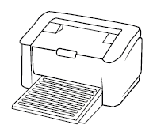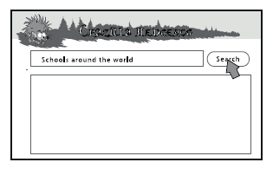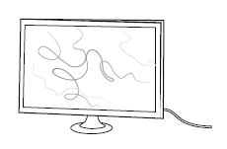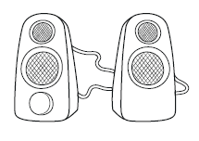
0 printer 1 ____________ 2 ____________ 3 ____________
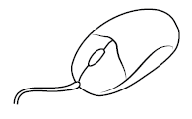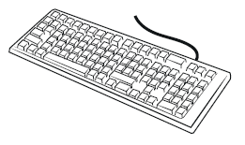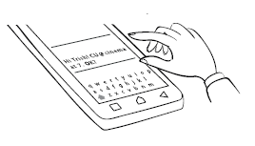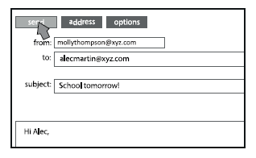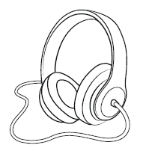
4 ____________ 5 ____________ 6 ____________ 7 ____________ 8 ___________
______ / 8

3.3 Feelings B
2 Uzupełnij zdania odpowiednimi przymiotnikami. Pierwsza litera każdego z nich została podana.
0 I have a new puppy and I’m happy!
1 My brother always takes my things without asking. I hate it! I’m a____________.
2 Dad is late and I’m w____________. What’s wrong?
3 My parents work a lot and they feel t____________ in the evening.
4 He doesn’t like me and I feel s____________.
5 Every day is the same and she’s b____________.
______ / 5

3.5 Adjectives with prepositions B
3 Uzupełnij zdania, używając about, at , in lub of.
0 Fred is good at tennis. He’s the school champion.
1 She’s excited ____________ her birthday party on Friday.
2 I can’t play chess. I’m bad ____________ it.
3 They’re interested ____________ history and science.
4 Why are you scared ____________ snakes?
5 I’m worried ____________ you. What’s the matter?
______ / 5
Total score: ______ / 18

