LISTENING
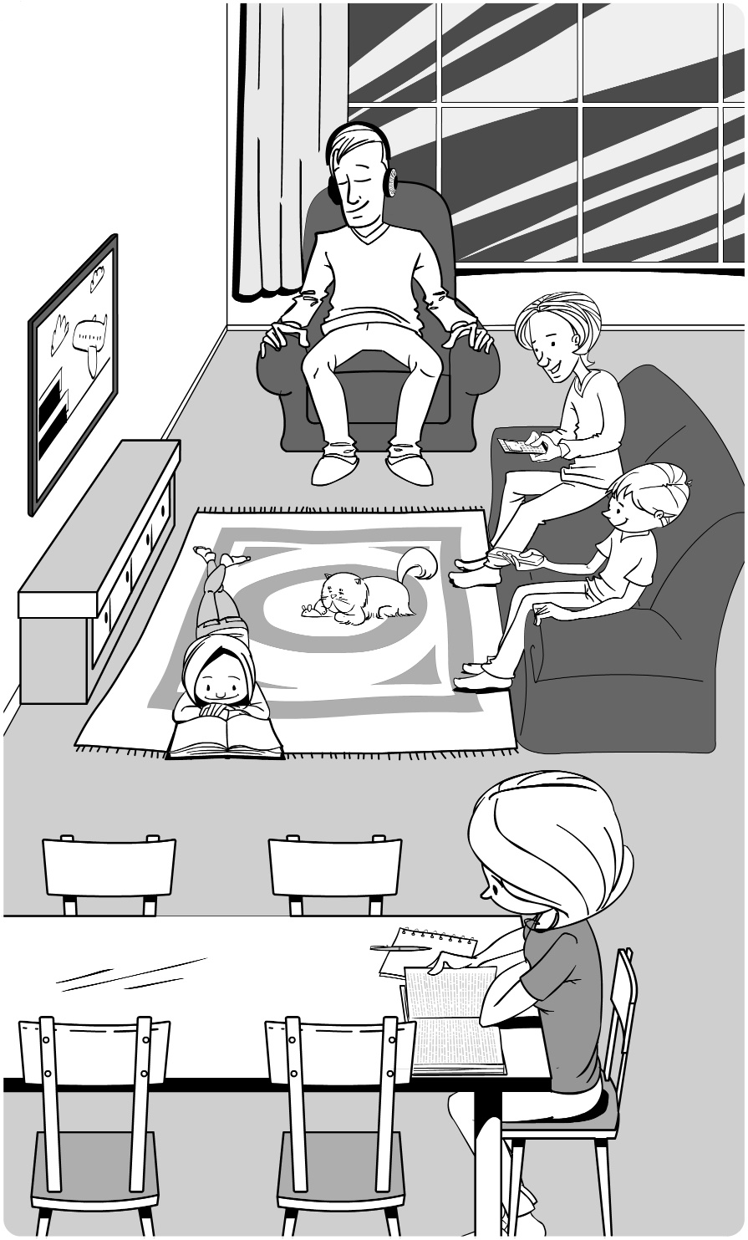
1 [Track 3] Posłuchaj nagrania i dopasuj osoby 1–5 do postaci a-e na obrazku.

0 Mum _f_
1 Dad ___
a
2 Sabina ___
3 Dennis ___
4 Muppet ___
5 Lawrence ___
ba

c

dc

e

f

______ / 5
VOCABULARY
2 Uzupełnij słowa.
Young people love technology. We can’t live without it! We love taking ⁰ s e l f i e s with our mobile phones. We ¹ s _ _ f the Internet a lot too. My friends and I have a computer at home: some people have got a tablet too, and other people have got a ² l _ _ t _ _. We usually ³ d _ _ _l _ _ _ songs and we use our ⁴ h _ _ _ p _ _ _ e _ to listen to music. We sometimes ⁵ s _ n _ emails but we usually ⁶ t _ _ t our friends or we ⁷ c _ _ t online.
______ / 7
3 Wybierz poprawne odpowiedzi.
0 I’ve got a new laptop! I’m happy / scared / tired.
1 Barry is angry / excited / scared of big dogs!
2 I am interested / worried / scared about my friend. He looks sad.
3 Are you interested / bad / bored in Science and Technology?
4 Sandra isn’t interested / scared / good at playing chess, but her brother is fantastic.
5 Paul works all week so he feels excited / tired / interested at the weekend.
______ / 5
GRAMMAR
4 Uzupełnij luki słowami z nawiasów w czasie Present Continuous. Użyj form skróconych tam, gdzie to możliwe.
Max: Hi, Granny! Yes, we’re all fine. I ⁰ ’m sitting (sit) in the garden. Bert? Oh, Bert ¹ _______________ (do) his homework in his bedroom. And Mum, Uncle Darren and Aunt Vicky are in the living room. They ² ________________ (talking). No, Dad ³ ________________ (not watch) TV. He ⁴ ________________ (sing) in the shower. I can hear him! What ⁵ ________________ (you / do)?
______ / 5
5 Uzupełnij dialogi, wpisując krótkie odpowiedzi.
0 A: Are Billy and Marcus chatting with their friends?
B: Yes, they are.
1 A: Is Jenny going to the library?
B: No, ________________.
2 A: Are you and your family having dinner?
B: Yes, ________________.
3 A: Is the boy listening to music?
B: Yes, ________________.
4 A: Are Ian and Vanessa studying for a test?
B: No, ________________.
______ / 4
6 Uzupełnij pytania o podkreślone fragmenty zdań.
0 A: Where is your dad going?
B: My dad is going to work.
1 A: Are __________________________________ in the staff room?
B: No, the teachers aren’t sitting in the staff room.
2 A: What __________________________________?
B: Louisa is drinking orange juice.
3 A: Why are __________________________________ home?
B: Kate and I are going home because it’s late.
4 A: Where are __________________________________?
B: The little girls are playing in the garden.
______ / 4
SPEAKING
7 Uzupełnij słowa.
Simon: Hello, Mrs Winters. It’s Simon ⁰ here.
Mrs Winters: Hello, Simon. How are you?
Simon: I’m ¹ f________________, thanks. Can I² s________________ to Gabriella, ³ p________________?
Mrs Winters: ⁴ J________________ a minute. Gabriella! It’s Simon for you.
Gabriella: Hi, Simon.
Simon: Hi, Gabriella. Do you want to go skateboarding with me?
Gabriella: That’s a good idea. See you ⁵ l________________.
______ / 5
READING
8 Przeczytaj tekst. Zaznacz, czy podane zdania są prawdziwe (P), czy fałszywe (F).
0 Chiara and Jared often meet online. P / F
1 Chiara is downloading music to her smartphone right now. P / F
2 Chiara enjoys taking selfies. P / F
3 Jared often reads e-books on his smartphone. P / F
4 Chiara is watching a music video now. P / F
5 Jared and Chiara are chatting online right now. P / F
______ / 5

Online friends
Most teenagers have smartphones now. Thanks to the Internet, they can talk to friends from all over the world. Chiara and Jared are online friends - they tell us how they use their smartphones.
Chiara: I’m Italian and I live in Rome. I usually use my smartphone to go online and to text my friends. I sometimes download music to my phone and listen to it on my headphones. I often use my smartphone to chat with my classmates and take photos for our school project as well. I never take selfies – I think they’re boring! Right now I’m using my smartphone to chat with Jared – we usually meet online once or twice a week.
Jared: I’m English and I live in Leeds. I don’t like calling my friends on my smartphone – I prefer to text them. I often play games on my smartphone or read e-books – the screen is small so I can do it on the bus on my way to school. At home, I often go online to look for information for my school projects. Right now I’m chatting to Chiara – she’s my online friend from Italy. I’m asking her to watch a new video from my favourite band!

WRITING
9 Przeczytaj zadanie i napisz tekst.
Write 60–70 words about the technology you use every day. Use questions 1–5 to help you.
1 What is your favourite item of technology?
2 What do you do with it?
3 What other items of technology do you use a lot?
4 What do you do with them?
5 What do your parents think of technology?
______________________________________________________________________________________
______________________________________________________________________________________
______________________________________________________________________________________
______________________________________________________________________________________
______________________________________________________________________________________
______________________________________________________________________________________
______________________________________________________________________________________
______________________________________________________________________________________
______________________________________________________________________________________
______________________________________________________________________________________
______________________________________________________________________________________
______________________________________________________________________________________ ______________________________________________________________________________________
______ / 10
Total: ______ / 50

